Detailed analysis of Boston and Seattle Airbnb Data

## **A data analysis using Airbnb listings data for Boston and Seattle**

# Airbnb: Seattle vs Boston - Lakshmi Kumar Katikala - Medium

# Introduction

Are you wondering how Airbnb host fix rental price for their apartment/house? What can we decipher from Boston and Seattle Airbnb dataset?

*Is there any noticeable difference between the datasets of Seattle and Boston Airbnb?*

*What are the most significant features to estimate Airbnb rental price?*

*What are the top amenities people needs most?*

Lets try to figure out the answers of these questions!

# Quick Glance at Seattle and Boston

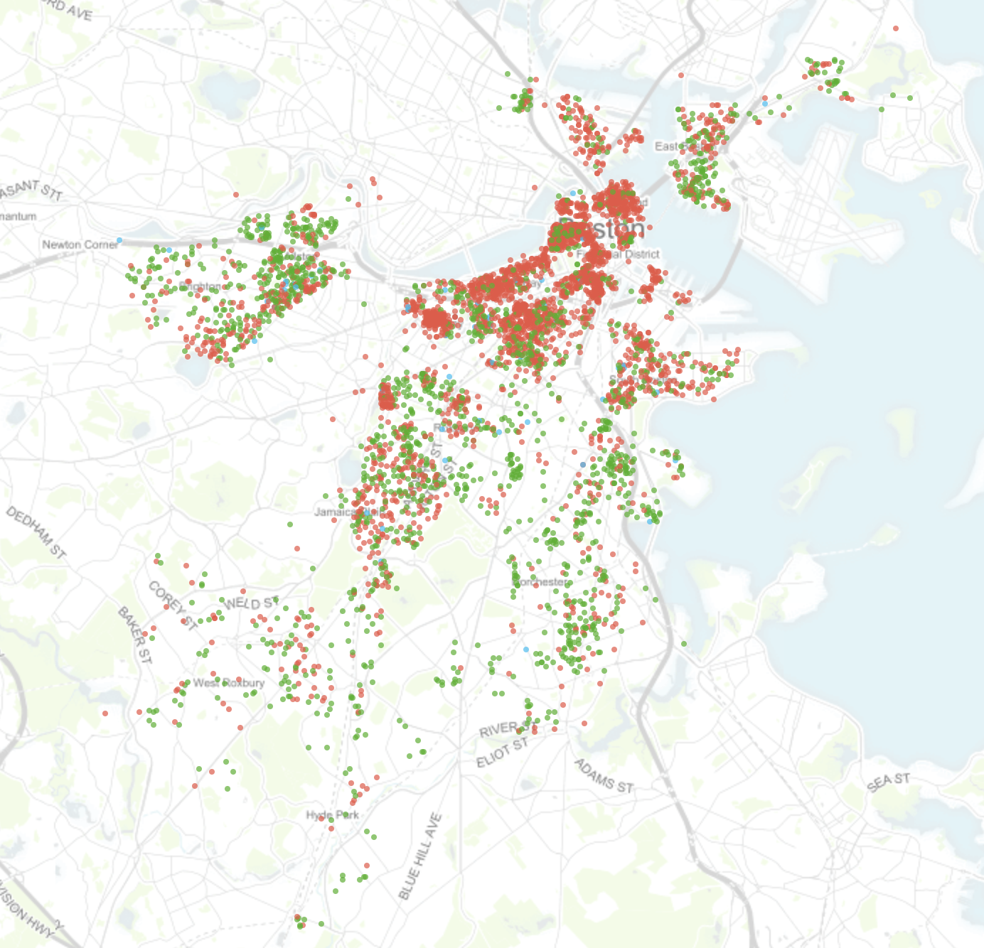

Boston Airbnb Listings

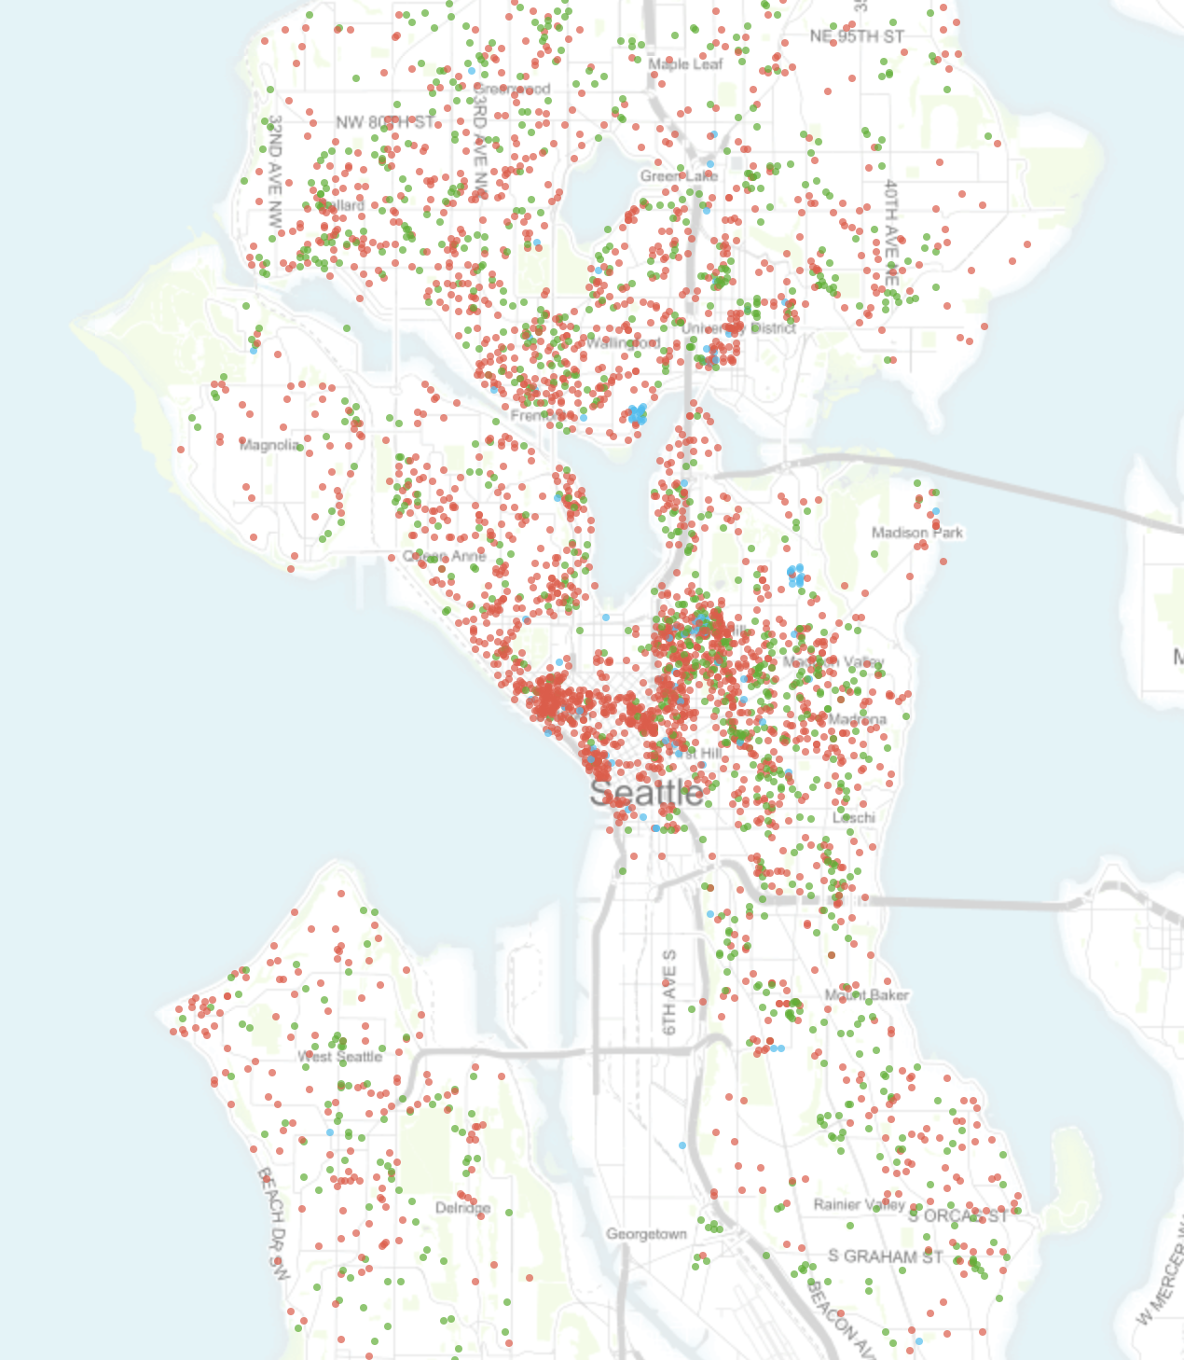

Seattle Airbnb Listings

From the data provided by mid August 2018, Boston has 6036 listings with an average of $184/night while Seattle has 8494 listings with an average of $152/night. To give a more detailed pricing, 75% of Boston listings lies below $219/night while 75% of Seattle listings lies below $189/night which suggests the rental price for Airbnb in Seattle is slightly cheaper than in Boston.

The most expensive list in Boston is $3999/night while in Seattle the most expensive one is $5400/night.

Airbnb hosts can mark entire homes/apartments (red), private (green) or shared rooms (blue). In Boston, hosts listed their room type as 62.2%, 36.6% and 1.2% respectively for the above 3 room types. While in Seattle the room type percentage is 66.6%, 30.4% and 3.1% respectively.

Let’s take a deeper look at data and use them to estimate the rental price of Airbnb in Boston and Seattle.

# Predicting Rental Price in Boston and Seattle

As 99% of the listing price are below 500, so I choose to drop the rows above 500 to get a more stable prediction. Missing values were filled by median value or most frequent value based on some other related features.

GradientBoostingRegressor was used to classify both the datasets and a five-fold GridSearchCV was applied to find the best hyperparameter for the classifier.

On the other hand, 1/5 of the pre processed dataset was used as test data and the remaining 4/5 are used to train ML model.

# What are the Most Important Features to Predict Rental Price?

I listed top 20 features for both cities which plays the most important role in predicting rental price. Let’s take a look how they look like.

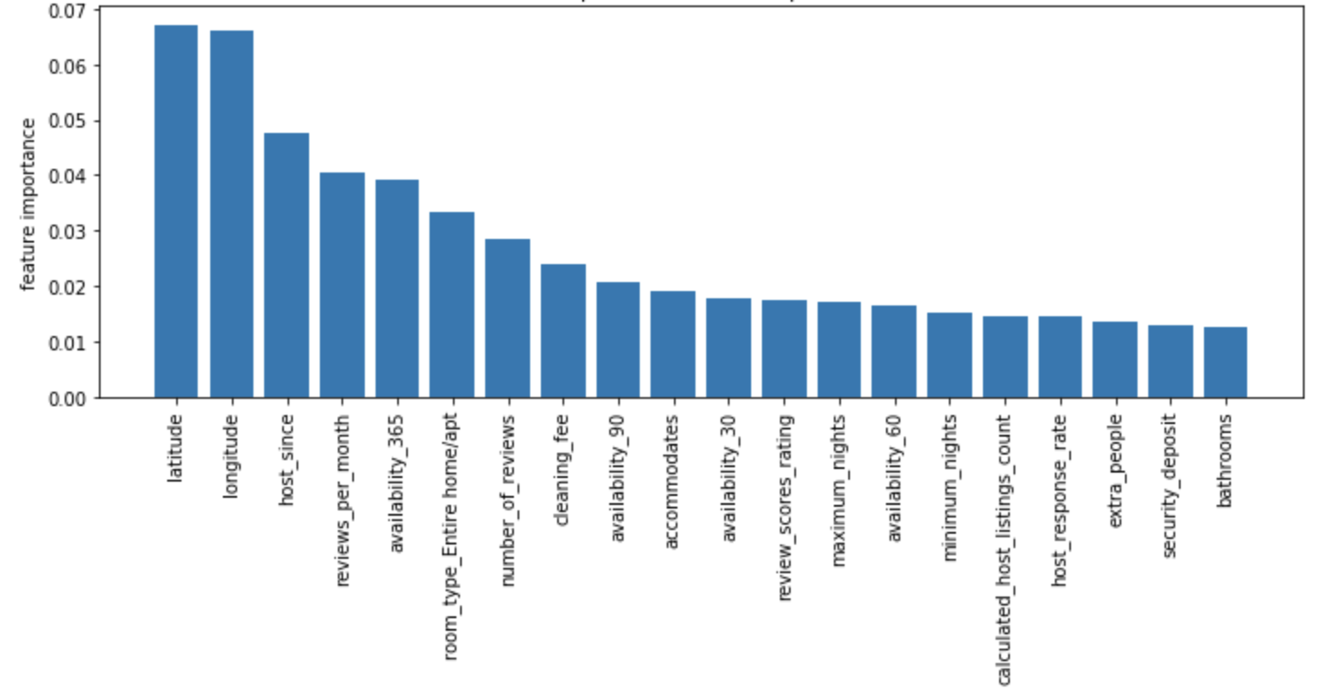

Top 20 Features to predict Boston Rental Price

It is no surprise that latitude and longitude are one of the top important features, as rental price are highly depend on the location of the property. Host_since feature represents when the host start their journey with Airbnb, if a host start airbnb earlier they probably had more experience attracting people and know how to make their guest more comfortable. Reviews_per_month and number_of_reviews tell us people are willing not only stay there but also leave a comment, which means they enjoy the stay. Some other features such as accommodates, security_deposit and bathrooms are also among the top list.

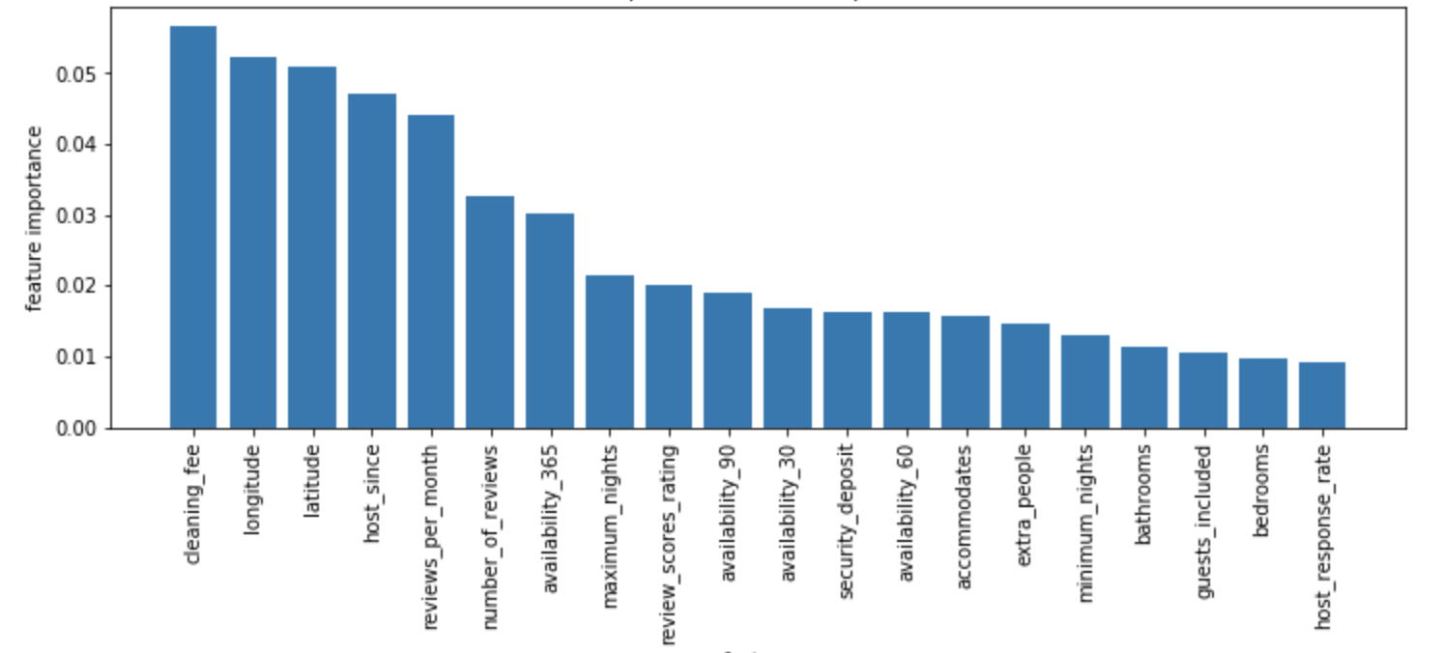

Top 20 Features to predict Seattle Rental Price

In Seattle, features are equally important. There are some new features such as host_response_rate, extra_people and guest_included. But most of the top features are shared with Boston machine learning model. We can see cleaning_fee is the most important feature here, as more cleaning needs result from larger room, probably more bathrooms and more services.

# What are the Top Amenities to Pay Attention?

After training machine learning model, we can now check how amenities influence the price prediction/how important are they.

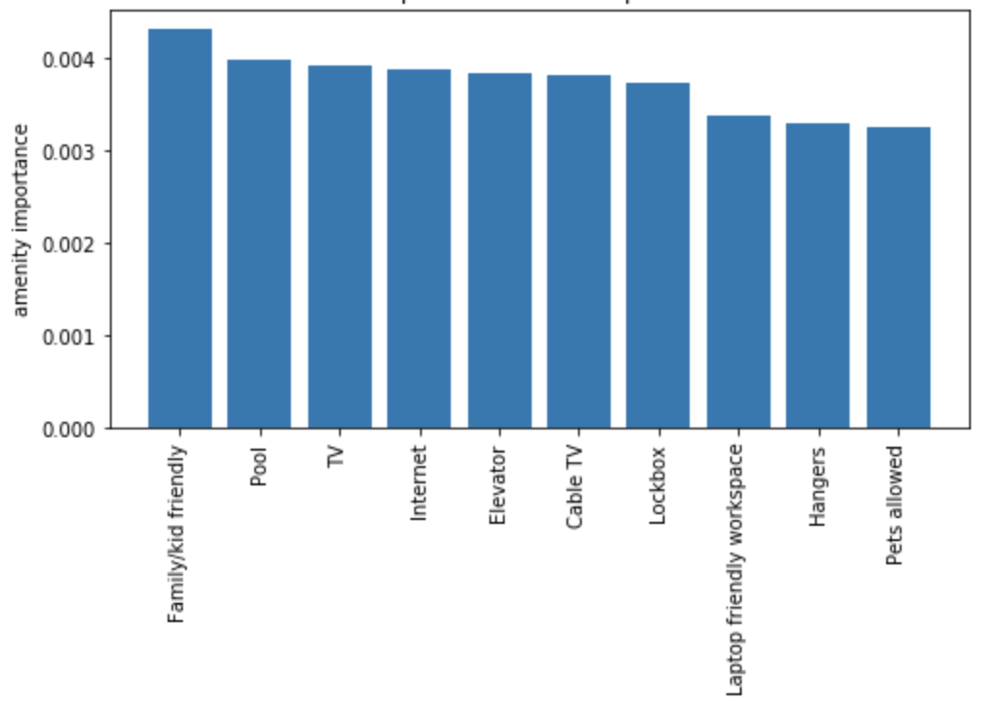

Boston Top 10 Important Amenities

In Boston, amenities like TV, Internet lockbox and hangers are important as expected. Familiy/kid friendly is also a feature which most of the travellers will consider. We can see if you have a pool in your property, you might have more confidence in raising your rental price. One interesting phenomenon is Airbnb has more amenities listed in Seattle (168) than Boston (120).

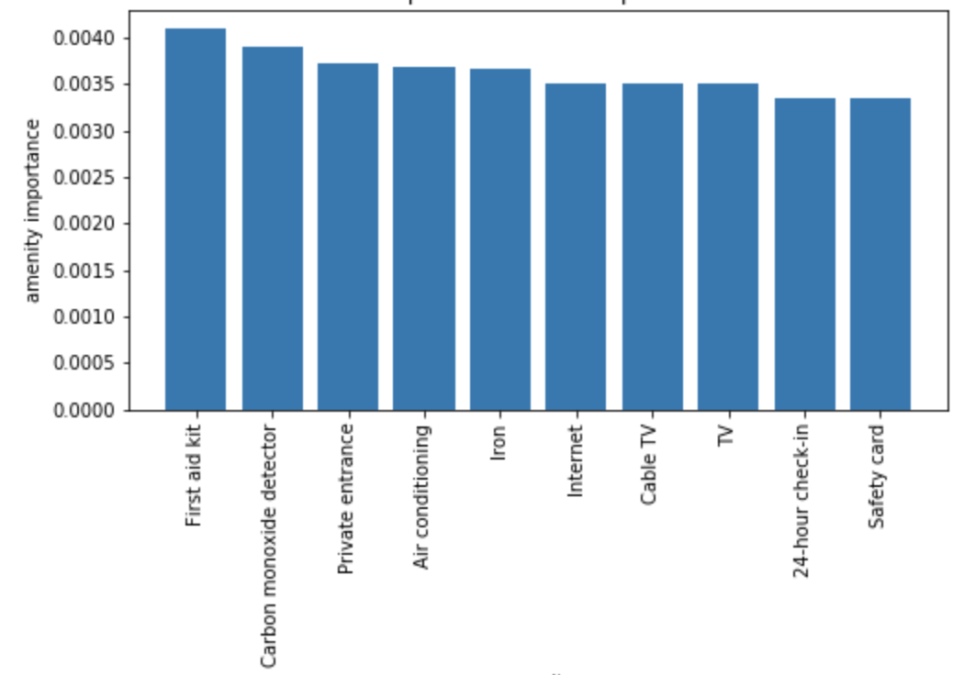

Seattle Top 10 Important Amenities

Seattle hosts has certain extra amenities than Boston’s such as **Amazon Echo, Heated Floors, Formal Dinning Area and Memory Foam Mattress.** We can see the importance of amenities are not as high as other features in the last section.

In Seattle, the most important amenities seems to be the First aid kit, while TV and Internet are also in the top 10.

## Conclusion

In this blog, we dive into the most recent Airbnb Boston and Seattle dataset and found many interesting phenomenon like:

*We gathered the Boston and Seattle Airbnb datasets, and compared the two.*

*We established a machine learning model to predict the rental price for both cities.*

*We took a look at the feature importance of the trained model and checked if they make sense.*

*We list all the important amenities to get a better feeling on how host can make more money by providing better services to meet customers’ need.*

I wrote this blog as a part of udacity’s data science nanodegree course. Ofcourse a lot can be done in the future such as studying the reviews provided by the customer.